VS Code Installation

1. Download VS Code Installer:

Go to the official Visual Studio Code website: https://code.visualstudio.com/
Click on the "Download for Windows" button.
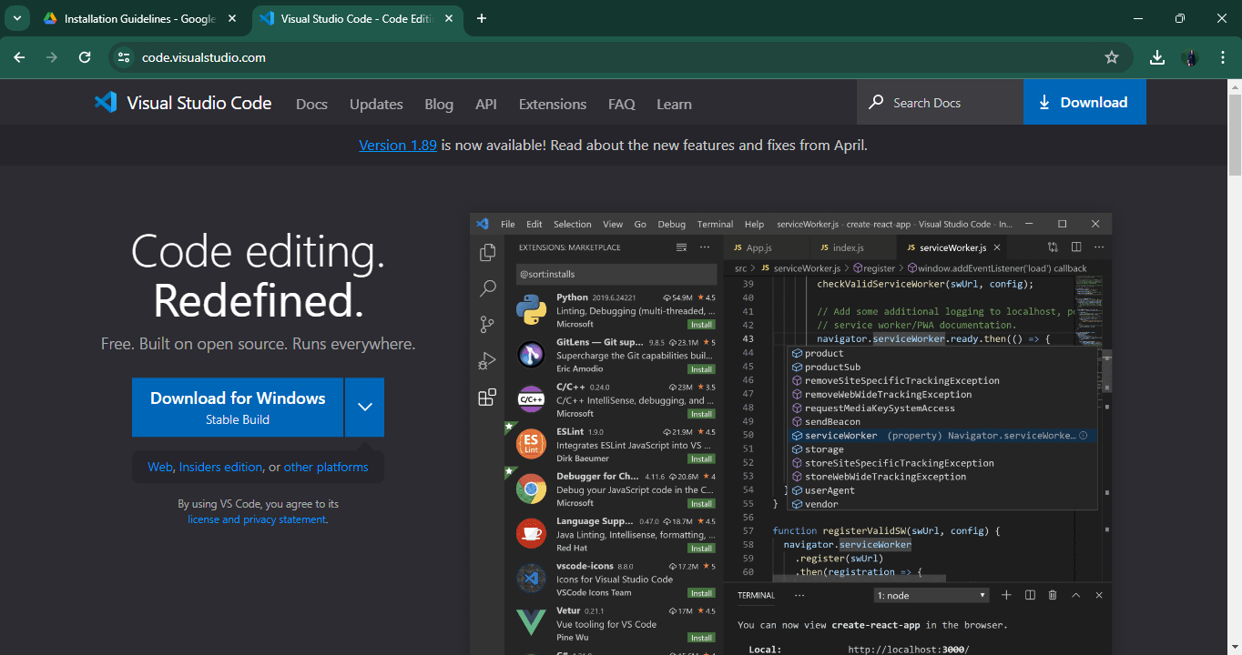
Figure 1: VS-Code Download Site

2. Run the Installer:

Once the installer is downloaded, locate it in your downloads folder or wherever you saved it.
Double-click on the installer file (VSCodeSetup-{version}.exe) to start the installation process.
Accept License Agreement:
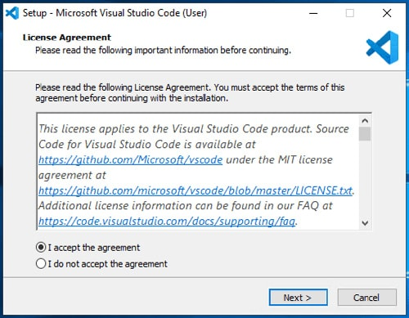
Figure 2: VS-Code Agreement
The installer will prompt you to accept the license agreement. Read through it and if you agree, click on the "I accept the agreement" checkbox.

3. Choose Installation Options:
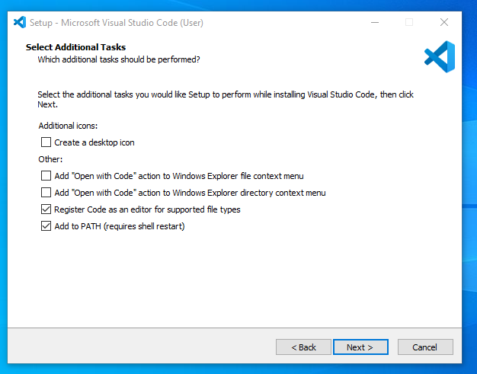
Figure 3: VS-Code Setup
You can choose whether to create a desktop icon, add VS Code to the PATH environment variable, and associate file types with VS Code.
Customize these options according to your preference and click "Next".

Select Destination Location:
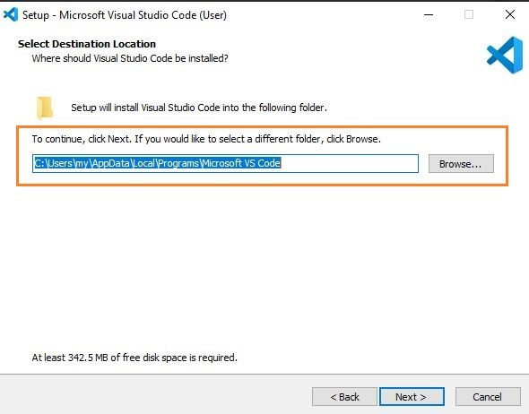
Figure 4: VS-Code Location Setup
Choose the location where you want to install VS Code. The default location is usually C:\Program Files\Microsoft VS Code.
Click "Next" to proceed.

Select Start Menu Folder:
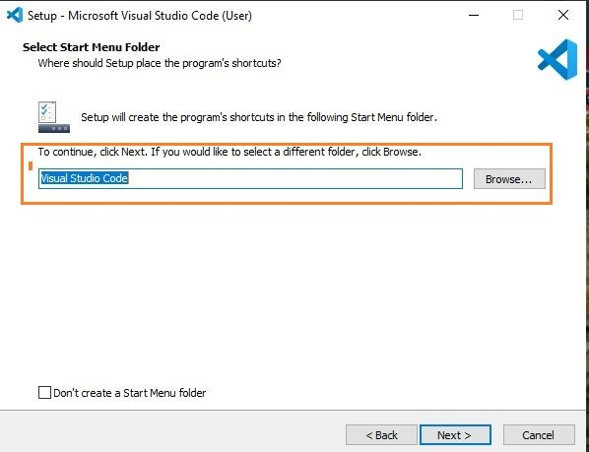
Figure 5: VS-Code Shortcut place
Choose the folder where you want to create shortcuts in the Start menu. You can leave the default selection.
Click "Next".

Install VS Code:

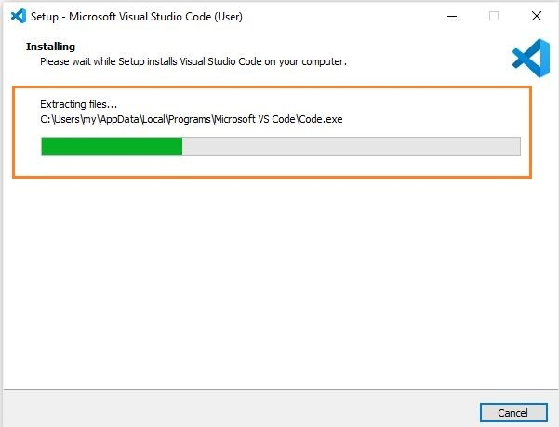
Figure 6: VS-Code Installation
Click on the "Install" button to start the installation process. This might take a few moments depending on your system's speed.
Complete Installation:
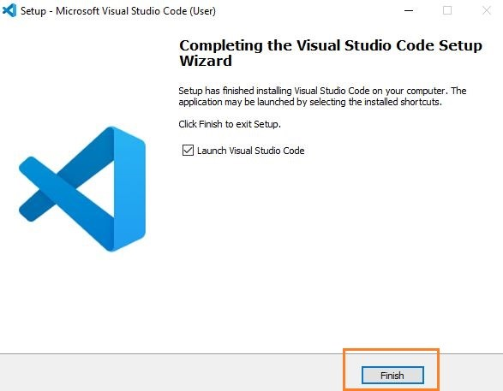
Figure 7: Finish VS-Code Installation
Once the installation is complete, you'll see a "Completing the Visual Studio Code Setup Wizard" screen.
Ensure that the checkbox for "Launch Visual Studio Code" is checked if you want to open VS Code immediately after installation.

Click "Finish" to exit the setup wizard.

Launch Visual Studio Code:
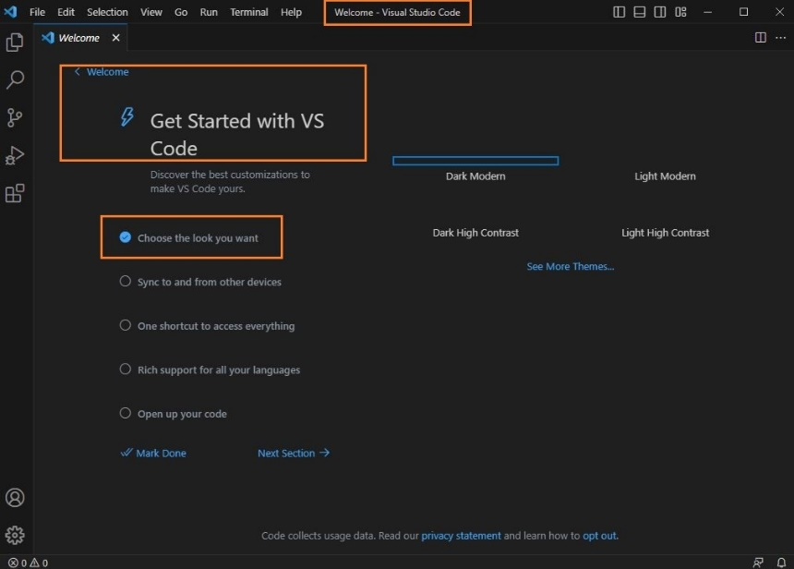
Figure 8: Launch VS-Code
If you chose to launch VS Code after installation, it will open automatically. Otherwise, you can find it in your Start menu or search for "Visual Studio Code" in the Windows search bar.

Flutter installation Guide:
- Download the flutter frontend folder.
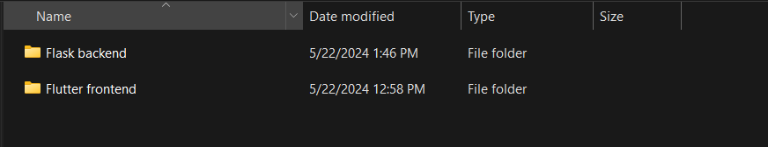

- Open Project in VS Code:
  - Open VS Code.
  - Go to File > Open Folder and select the flutter project directory.

- Install Flutter and Dart Extensions:
  - Open the Extension view in VS Code
  - Search for and install the following extensions:
    - Flutter
    - Dart

- Configure Flutter Project
  - Open terminal in VS Code
  - Navigate to the project directory
  - Run: flutter pub get

- Add Firebase Dependencies:
  - Open the ‘pubspec.yaml’ file in flutter project.
  - Add the required dependencies:
    - firebase_core: latest_version
    - firebase_auth: latest_version
    - cloud_firestore: latest_version
  - Run: flutter pub get

- Select Android emulator:
  - Select which android emulator to run
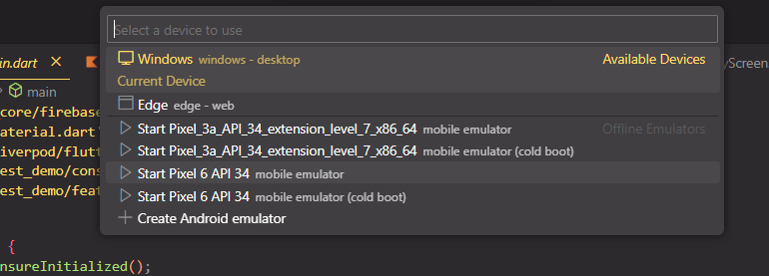

- Run the Flutter Application:
  - Run the flutter app using the terminal or VS Code’s debugger.
With this the build is complete and the app will open in the emulator:
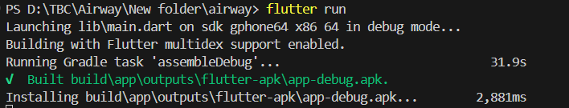

Firebase Installation
- Install FlutterFire CLI: Ensure you have Node.js installed, then install the FlutterFire CLI globally: npm install -g firebase-tools, npm install -g flutterfire_cli
- Login to Firebase: Authenticate your Firebase account using the CLI: firebase login
- Initialize Firebase in Your Flutter Project: Navigate to your Flutter project directory and run the FlutterFire CLI to configure Firebase: flutter configure
    - Follow the prompts to select the Firebase project and platforms you want to configure (iOS, Android, Web).
- Add Firebase SDK Dependencies: Open your pubspec.yaml file and add the necessary Firebase dependencies. For example:
- Run Flutter Packages Get: Fetch the newly added dependencies: flutter pub get
- Initialize Firebase in Your App: Initialize Firebase in the main.dart file: firebase.initializeApp();

